Experiment 03

Name : Iqra Shaikh
Rollno: 24DCO06

AIM : To perform CRC for error detection Cyclic Redundancy Checking

The cyclic redundancy check (CRC) is a technique used to detect errors in digital data. CRC is a hash function that detects accidental changes to raw computer data commonly used in digital telecommunications networks and storage devices such as hard disk drives. CRC uses Generator Polynomial which is available on both sender and receiver side.

n : Number of bits in data to be sent from the sender side.
k : Number of bits in the key obtained from the generator polynomial.

CODE :

datastream = input("Enter datastream (in binary): ")
divisor = input("Enter divisor (generator polynomial in binary): ")

l_key = len(divisor)
dividend = datastream + '0'*(l_key - 1)
pick = l_key
tmp = dividend[0:pick]

while pick < len(dividend):
if tmp[0] == '1':
result = []
for i in range(1, l_key):
result.append('0' if tmp[i] == divisor[i] else '1')
tmp = ''.join(result) + dividend[pick]
else:
result = []
for i in range(1, l_key):
result.append('0' if tmp[i] == '0' else '1')
tmp = ''.join(result) + dividend[pick]
pick += 1

if tmp[0] == '1':
result = []
for i in range(1, l_key):
result.append('0' if tmp[i] == divisor[i] else '1')
remainder = ''.join(result)
else:
result = []
for i in range(1, l_key):
result.append('0' if tmp[i] == '0' else '1')
remainder = ''.join(result)

codeword = datastream + remainder
print("Codeword (Sender):", codeword)
Output:
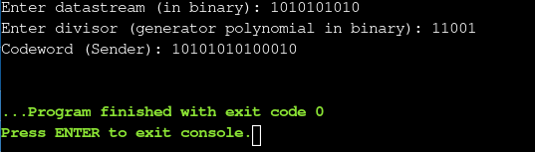

CONCLUSION:

This experiment demonstrated how CRC effectively detects errors in digital data by generating a codeword using a generator polynomial. The process ensures data integrity during transmission, highlighting CRC's importance in reliable communication systems.

